**Lab – 1: How to get started with EMS?**

**Objective:** The objective of this lab is –

* To get started with the EMS Enterprise Mobility + Security Suite.

Enterprise Mobility + Security provides additional protection for Office 365 and expands your capabilities to help you securely deliver all of your apps to any device, safeguard your corporate assets everywhere, and protect your infrastructure both on-premises and in the cloud.

**Prerequisite:** EMS Enterprise Mobility + Security E5 Trial.

**Steps:**

1. So, to get started with EMS, open a link - **https://www.microsoft.com/en-us/cloud-platform/enterprise-mobility-security-trial**, in your browser. And, click **Try now** button to get started with EMS. You will be redirected to another link that is - https://signup.microsoft.com/Signup?OfferId=87dd2714-d452-48a0-a809-d2f58c4f68b7&ali=1.

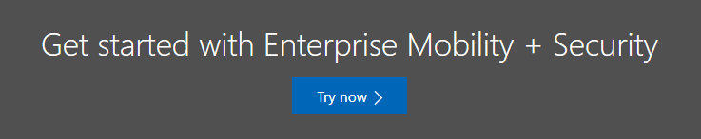

1. A registration link will open for EMS Enterprise Mobility + Security E5 Trial. If you have already created an account for this, you can click on **Sign in** option at the top right corner and enter your credentials to get login to your EMS account.

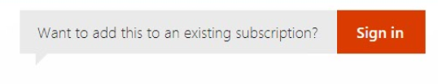

Otherwise, fill the form and Click **Next**.

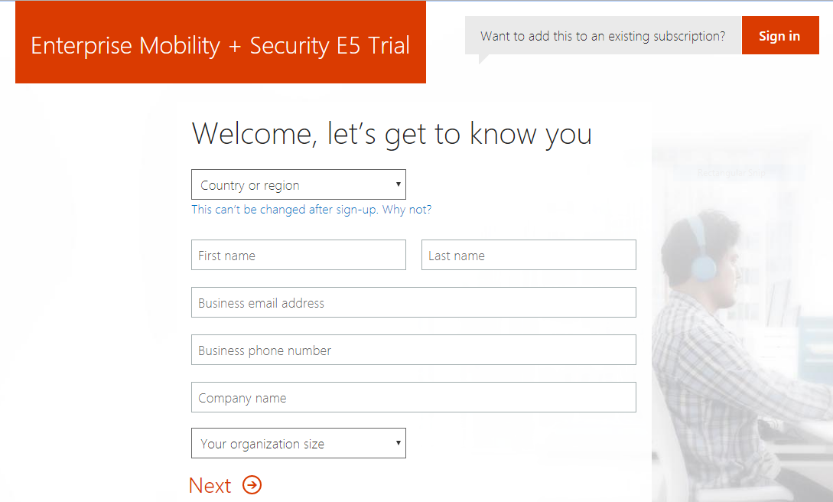

1. Then create your **User ID** and **password**.

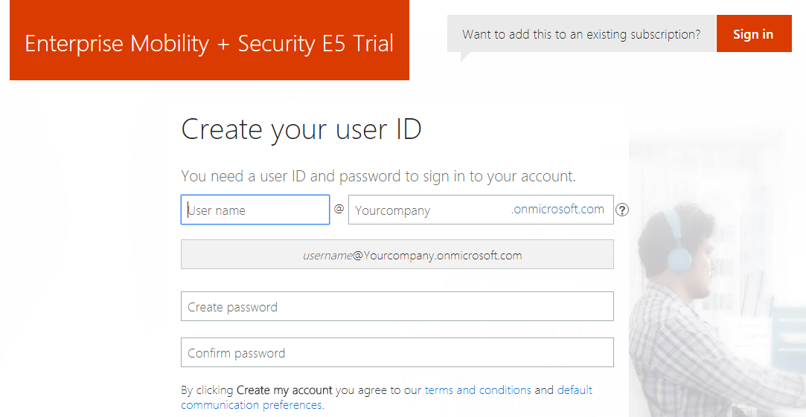

1. Then click **Create my Account**. Then it will ask you to prove you’re not a Robot. For this, select **Text me**, if you want to receive a code as a text message or either you can select **Call me** if you want to receive a code on a voice call. Then enter your Phone Number, and click **Text me** or **Call me**, as according to your selection.

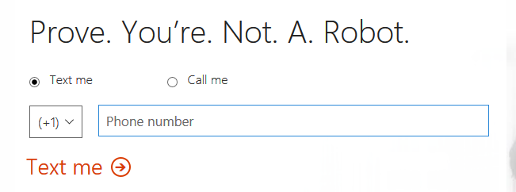

1. Then, **enter your verification code** and click **Next**.
2. Then you will receive Sign-in page link and your User ID. So, you can save this information for your later use and click **You’re ready to go…**.

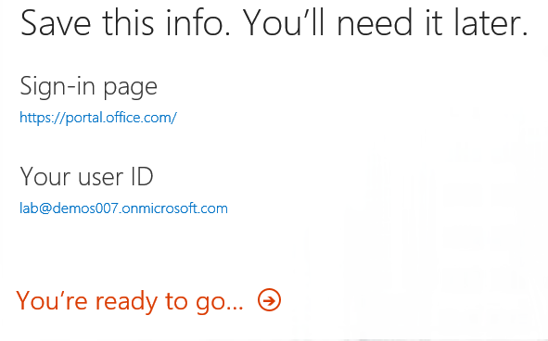

1. And, now you can get started with Enterprise Mobility + Security. When you click **You’re ready to go…**,you will be redirected to <https://www.microsoft.com/en-us/cloud-platform/getting-started-ems>.

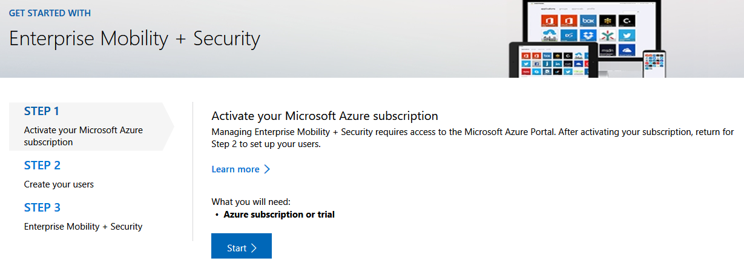

1. So, in this way you can get started with EMS.